**호흡기바이러스 1Step 테스트용 바코드 (2022.09.29 제작) // 500 size Calibration Marker**

**VEUDx LOT/V1/EZRE22092901/Respiratory-Virus-1Step/221229/1_a3507.979125_b1.130559_c249929.555076_d38057004.035657/3_a3427.628697_b0.940849_c533837.496638_d39832549.230105/5_a3427.628697_b0.940849_c533837.496638_d39832549.230105/7_a3427.628697_b0.940849_c533837.496638_d39832549.230105**

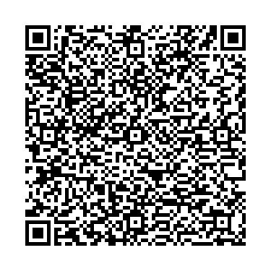

**VEUDx Strip/V1/EZRE22092901/Respiratory-Virus-1Step/221229**

